Booking Form

For all enquiries and to book a table please call: 023 9258 2157
24 Crescent Road, Alverstoke, Gosport
PO12 2DH
info@angleseyhotel.co.uk
Name:
Address:
Telephone:
Email:
Number in party:
Total deposit @ £5 per head:
Date of booking:
Sit down time:

Menu pre order
Name | Starter | Main | Dessert
Please continue on a separate sheet if necessary

Booking Conditions: for all menus:
- A deposit of £5 per head will be required for all bookings
- Any cancellations less than 24 hours prior to the meal will incur the full charge
- Prior ordering is necessary on all bookings of 8 or more
- An optional service charge of 10% will be added to the bills
- Sole use of the restaurant is only available for parties of 30 or more

*I agree to the conditions set out in this menu
Signed: Date:

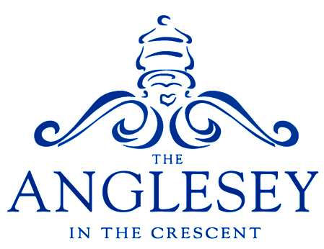

Festive Menu

24 Crescent Road, Alverstoke, Gosport, PO12 2DH
www.angleseyhotel.co.uk

Menu

Moroccan cauliflower vegan/gf
Sesame seeds, sliced chilli, pomegranate and chilli jam

Smoked salmon gf option
Beetroot mayonnaise, herby croutons and water cress

Halloumi baked mushrooms gf/v/vegan option
With sliced pimentos and a chilli herb dressing

Ham hock terrine
Piccalilli, cherry tomato and crusty bread

~~~

Turkey with a difference gf
Turkey parcels wrapped around our famous Christmas stuffing. Finished
with smoked bacon and served with roast potatoes, roasted root vegetables, broccoli, pigs in blankets and gravy

Roast cauliflower steak gf/vegan
Vegan pigs in blankets, roast potatoes, roasted root vegetables, broccoli
and vegan gravy

Herb crusted cod fillet gf
Stewed tomato, white wine and onion sauce with broccoli and new potatoes

Classic braised beef bourguignon gf
Creamy mash, slow cooked bacon and mushrooms, root vegetables,
broccoli and gravy

Our homemade Christmas burger
Topped with brie, cranberry and pigs in blankets with slaw and chips

~~~

Christmas pudding
Brandy cream and orange syrup

Biscoff cheesecake
Toffee sauce and fudge pieces

Chocolate and praline brownie vegan/gf
Chocolate syrup

Caramel apple pie gf
Toffee sauce

Cheese Board
A selection of local and European cheeses with crackers and chutney
(£1.50 sur charge)

~~~

Tea/Coffee with Mini mince pies

Lunchtime £23.50 / Evening £25.00
(Evening price to include crusty bread and olives to start)

